**How to use powershell for s3 bucket**

**YOUTUBE -----(https://youtu.be/p5UNJjxhD1s)**

**To create the file in powershell:**

eg: cat >>filename.txt

**TO add the content in the file in powershell:**

**eg: Set-Content C:\Users\somas\music\buckets\ddd.txt 'enter the content'**

**(or)**

**Set-content filename ‘enter the content’**

follow the link:https://www.tutorialspoint.com/powershell/powershell_filesio_create_text.htm

**to see the content of the file in powershell:**

eg:Get-Content C:\Users\somas\music\buckets\ddd.txt

**to upload the file from local to s3 on powershell:**

eg: aws s3 cp jjj s3://happy121

**jjj**------source name(filename); **s3://happy121**-----destination(happy121 is bucket name)

to refer this comment: <https://stackoverflow.com/questions/68675602/powershell-copy-files-to-aws-bucket-with-object-lock>

**to create the folder inside the bucket in powershell:**

**eg:** aws s3 cp jjj s3://happy121/demo/

* (/)-------creates the folder and jjj file moves to demo folder

**To download the file from s3 bucket in powershell:**

Eg: aws s3 cp s3://happy121/demo ./

(./)----- present directory ku it will be moved

**To move the object from one bucket to another bucket in powershell:**

Eg: aws s3 cp s3://somma6565/jjj s3://tt6565

Somma6565---bucketname

Tt6565-----another bucket name

**To delete the object from the bucket in power shell:**

Eg: aws s3 mv s3://somma6565/jjj

**To list the s3 bucket in aws:**

Eg :aws s3 ls

**To delete the s3 bucket in powershell :**

Eg:aws s3 rb s3://soma

Rb----remove buckrt

**To create the bucket using powershell:**

Eg:aws s3 mb s3://ganga

Mb----make bucket

how to list the object in s3 bucket using cli command

eg: aws s3 ls s3://your-bucket-name

**To transfer the files from one region to another region using CLI:**

**Step by step:**

**1)create a s3 bucket in the target region, s3 from the amazon management console**

**2)create an folder inside that bucket if necessary.**

**3)Download and install “ amazon command line interface”**

**4)after installation, check whether aws is installed or not via “command prompt”**

**5)after installing , command: aws –version**

**6)Now, we will configure amazon with the command**

**7)cmd will prompt for**

**Access key id: from the IAM**

**Secret access key:from the IAM**

**Region:ap-south-1**

**Format default: json or yaml**

**8)After configuration, you may sync or copt the bucket from one region to another region.**

**9)command for sync:**

**aws s3 sync s3://source-bucket s3://destination-bucket --region new-region**

**destination bucket should be create (eg:soma):**

**aws s3 sync s3://source-bucket s3://soma –region new region**

**new-region should be given:**

**aws s3 sync s3://source-bucket s3://soma –region ap-south-1**

**How to create the MFA for the s3 bucket:**

**1)create a s3 bucket and make sure versioning is enable**

**2)Go to the IAM and set the MFA for the AWS console And scan QR code in your mobile.**

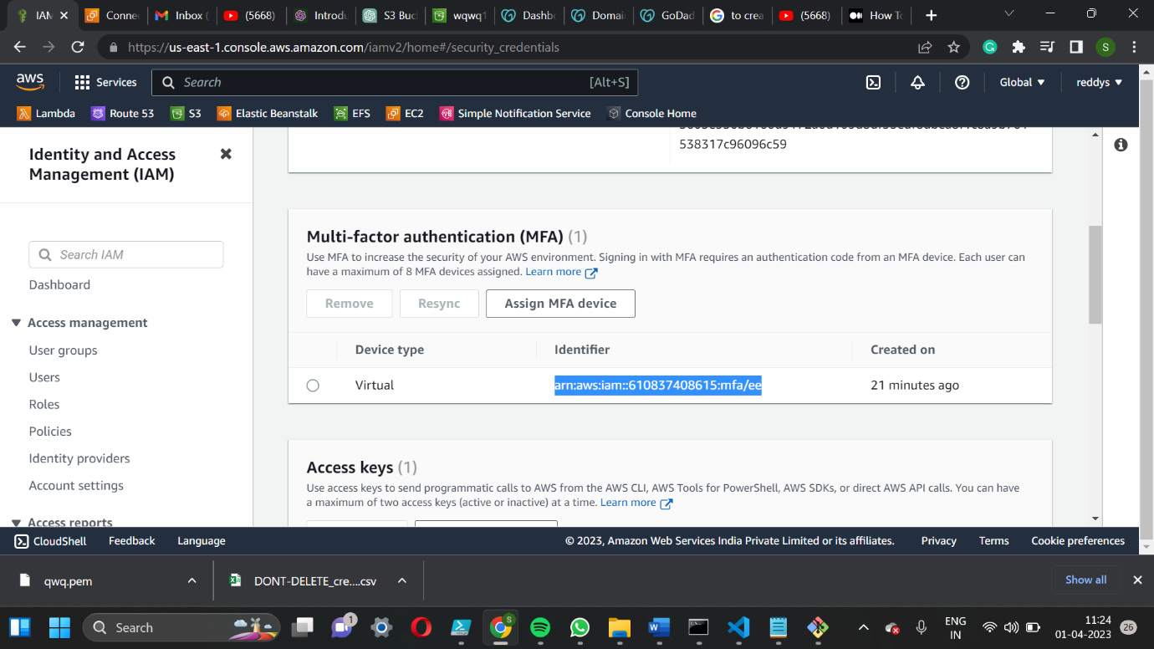

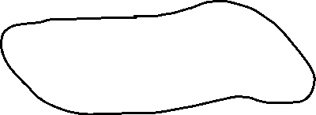

**3)In CLI(command line interface), we should configure the access key so below MFA they is a access key, go to that and create a secret key.**



**4) after installing CLI , command: aws –version**

**6)Now, we will configure amazon with the command :aws configure**

**7)cmd will prompt for**

**Access key id: from the IAM**

**Secret access key:from the IAM**

**Region:ap-south-1**

**Format default: json or yaml**

**7)After configuring make sure that s3 bucket versioning is enable**

**8) the command is:**

**EG:**

aws s3api put-bucket-versioning--bucket <bucket_name> --versioning-configuration Status=Enabled,**MFADelete=Enabled** --mfa “arn:aws:iam::<account number>:mfa/root-account-mfa-device <mfa_code>”



<bucket name> ---should enter the bucket name

<accoountnumber>----should enter the account number which was presented in MFA in IAM.



<MFA CODE> ----SHOULD enter the mfa code from the mobile.

ORGINAL COMMAND:

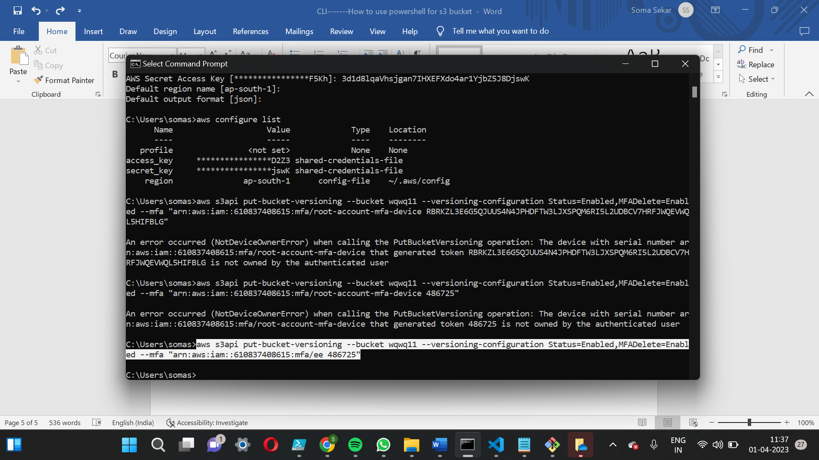

**Command:**

**aws s3api put-bucket-versioning --bucket wqwq11 --versioning-configuration Status=Enabled,MFADelete=Enabled --mfa “arn:aws:iam::610837408615:mfa/ee 609469”**

**9)after setting up the MFA for the bucket, upload the object to the s3 bucket.**

**10)And delete the object uploaded to the s3 bucket.**

**11)enable versioning for the object.**

**12)after enable the version there will be the delete marker for the object u cannot be delete delete marker without the MFA.**

**Please refer to the link:**

<https://blog.searce.com/how-to-enable-mfa-delete-s3-bucket-feature-ad3abb965301#:~:text=Login%20to%20AWS%20console%20as%20root%20user%20%2C%20Top%20most%20right,Account%20Name%20%E2%86%92%20Security%20Credentials.&text=Under%20Security%20Credentials%20now%20select%20Multi%2Dfactor%20authentication%20(MFA).&text=Note%20down%20the%20Serial%20Number,%2Dfactor%20authentication%20(MFA)>.

YOUTUBE LINK: https://www.youtube.com/watch?v=9ayCRLrZwq4

**How to disable MFA Delete Feature ?**

user want to Disable the MFA Delete feature on bucket in that scenario you can use below command.

Eg command:

aws s3api put-bucket-versioning --bucket mfadeletedemobucket --versioning-configuration Status=Enabled,**MFADelete**=**Disabled** --mfa "arn:aws:iam::022871422318:mfa/root-account-mfa-device 996424"



<bucket name> ---should enter the bucket name

<account number>----should enter the account number which was presented in MFA in IAM.



<MFA CODE> ----SHOULD enter the mfa code from the mobile.

**Original command:**

**aws s3api put-bucket-versioning --bucket yaml11 --versioning-configuration Status=Enabled,MFADelete=Disabled --mfa "arn:aws:iam::610837408615:mfa/ee 996424"**

After disabling the MFA Delete feature on bucket you can see the **status** using below command.

aws s3api get-bucket-versioning --bucket mfadeletedemobucket



$ aws s3api get-bucket-versioning --bucket mfadeletedemobucket

**After entering the above command result will be displayed below**

{

"Status": "Enabled",

"MFADelete": "Disabled"

}

$